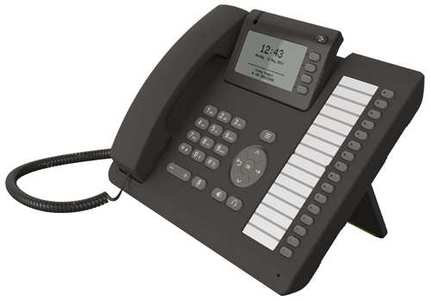
#
OpenScape Desk Phone CP400
#
OpenScape Desk Phone CP400

